Town of Gulf Stream
Palm Beach County, Florida

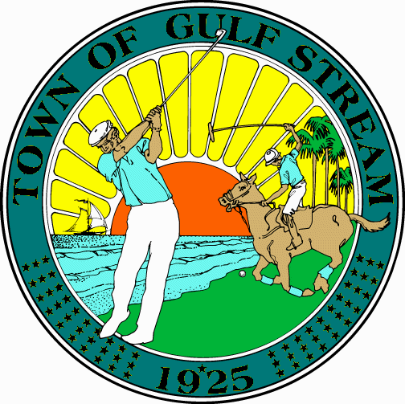

COMMISSIONERS

SCOTT MORGAN, Mayor
THOMAS M. STANLEY, Vice-Mayor
PAUL A. LYONS, JR.
JOAN K. ORTHWEIN
DONNA S. WHITE

Telephone
(561)276-5116

Fax
(561)737-0188

Town Manager
GREGORY L. DUNHAM

Town Clerk
RITA L. TAYLOR

Please be advised that your current Town of Gulf Stream Occupational Registration will expire on September 30, 2017 and must be renewed if you intend to perform work within the Town after that date. As a reminder, this is an occupational registration program, not an occupational license tax. All businesses performing work in the Town of Gulf Stream must obtain a Town Occupational Registration.

To obtain a registration, NEW COPIES of the following documents must be provided to the Town:

1. A VALID 2017 County Business Tax Receipt from the county in which your business is located. Registration cannot be obtained with a Local Business Tax Receipt for “SALES” (retail or wholesale), “MANUFACTURING” or “OFFICE.”

2. A VALID Certificate of General Liability Insurance and a VALID Certificate of Worker’s Compensation Insurance listing the Town of Gulf Stream as Certificate Holder. A valid Worker’s Compensation Exemption Certificate is acceptable in lieu of Worker’s Compensation insurance certificate if applicable. BINDER NUMBERS ARE NOT ACCEPTED, you must have an assigned insurance policy number.

3. If Florida State Certified or County Certified, a copy of the current Certification.

*Note: Documents may be faxed to the Town of Gulf Stream at (561) 737-0188 or e-mailed to
rtew@gulf-stream.org, however, until the fee is received in cash or check the registration will not be issued.

3. The NAME, TELEPHONE NUMBER & E-MAIL ADDRESS of the qualifier, business manager or owner.

4. Registrations include two vehicle decals. Vehicle decals are required for all company vehicles. Failure to properly display your decal may result in an immediate stop work order until the violation is corrected.

5. If you would like your registration and vehicles decals returned to you through the mail, a SELF-ADDRESSED STAMPED #10 ENVELOPE IS REQUIRED.

Registrations may be obtained, in person, at the Town Hall on non-holiday weekdays from 9:00 a.m. to 4:00 p.m. To register by mail, please use the address listed below. Please direct any questions regarding Occupational Registration to the Town Clerk’s office at 561-276-5116.
INFORMATION FOR
OCCUPATIONAL REGISTRANT

- Work is permitted in the Town of Gulf Stream from May 1 through November 30 on non-holiday weekdays and Saturdays from 8:00 A.M. until 5:00 P.M.

Note: During the period from December 1 through April 30, work is permitted only on non-holiday weekdays from 8:00 A.M. until 5:00 P.M.; and on non-holiday Saturdays during the same hours if work is conducted in a fully enclosed structure such that noise, dust, odors, vibrations, bright lights or similar effects from such activities are not detectable from other properties.

Pile driving, jack hammering, dry sand blasting and similar activities are prohibited from December 1 through April 30.

- Town Hall hours are from 9:00 A.M. to 4:00 P.M. Monday through Friday. Telephone (561) 276-5116. Fax (561) 737-0188.

- Please keep radios in use by workers at a minimum volume, out of respect to nearby residents.

- Trucks and other equipment shall not be parked on any property other than that where the work is being performed. Whenever possible, all parking shall be done off the traveled portion of the roadway.

- Commercial vehicles must display a valid Town Commercial Vehicle decal at all times. Decals should be placed (one per vehicle) on the driver’s side, REAR, bumper.

- Mowers and other gasoline-powered equipment must be filled with fuel somewhere other than the public street. The spillage from this type of work has caused the pavement to erode in a number of places.

* No work is allowed on the following holidays: New Year’s Day, Memorial Day, Independence Day, Labor Day, Thanksgiving Day and Christmas Day.

